The National Plan for Teaching Swimming – NPTS
At Beachfield Swimming Club we base our teaching on the UK National Plan for Teaching Swimming. .
This means that our lessons are well-structured. It means that our swimmers are taught properly. And it allows for their seamless progression from non-swimmer to advanced swimmer.

What is the NPTS?
The NPTS promotes the learning and development of swimming technique and skills. From your child’s first splash, through to full competence in the water in 10 stages. The NPTS is underpinned throughout by Long Term Athlete Development (LTAD) principles, with clear progression between each stage.

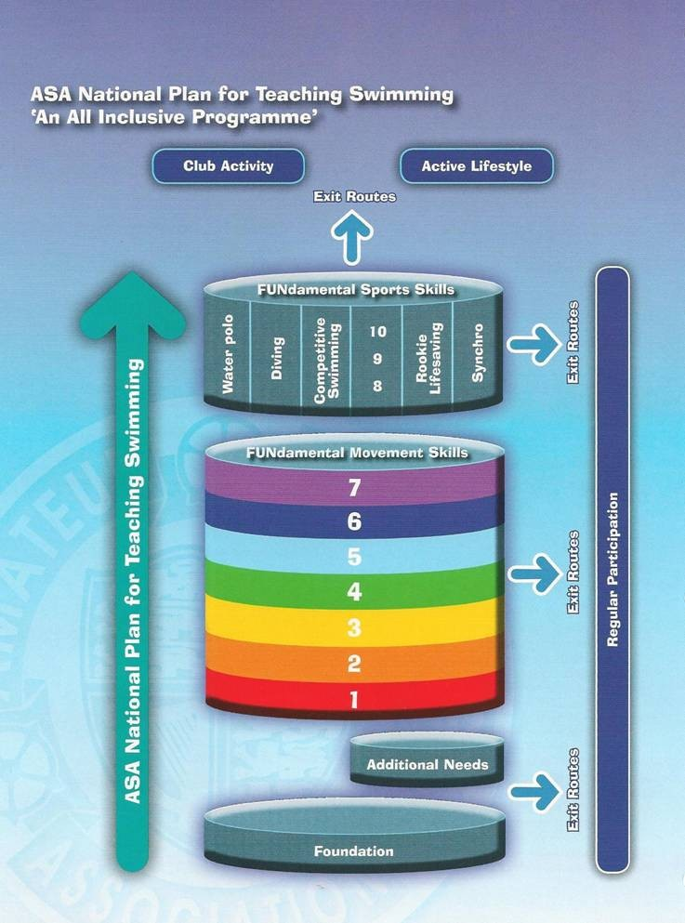

What’s this diagram all about?
The diagram shows the progression of children following the NTPS from non-swimmer to advanced swimmer. All children are encouraged to work towards and complete stage 7 to be competent and confident to enjoy swimming at their leisure and support a healthy lifestyle. Once children obtain stage 7 they can enjoy other water activities using the skills they have learned. These activities include competitive swimming, water polo, diving, synchronised swimming and lifesaving.
Every stage of the NPTS has specific outcomes and we encourage parents to recognise the key developmental steps their child will take.
Here’s a summary:

Fundamental movement skills

Stage 1 – WHITE Teaching Pool
This class is ideal for children who are confident in the water without a familiar adult. The primary focus is on developing basic safety awareness, social skills in a ‘class’ scenario, and basic movement skills. Children must have completed an adult and child class and be at least 3 years old to join this group lesson.

Stage 2 – WHITE Teaching Pool
This stage develops safe entries into the water, basic floatation skills and travelling up to 5m without support, on their front and back.

Stage 3 – WHITE Teaching Pool – with Introduction to widths
Children will progress to travelling 10m on their front and back without aids and have a greater understanding of balance, orientation and co-ordination. The children are expected to be able to complete 10m on their front and back, in deep water, to progress to stage 4.

Stage 4 –YELLOW Teaching pool Widths
At this stage we introduce breaststroke kick and develop front crawl and backstroke kick. Children will learn the importance of correct technique and streamlining skills over 15m.

Stage 5 –GREEN A/B Teaching Pool Lengths
Children will develop ‘watermanship’ through sculling, treading water and complete body rotation. They will develop the correct technique over 20m - front crawl, backstroke and breaststroke. We are looking for a continuous, relaxed style with an emphasis on the propulsive and glide stages of each stroke.

Stage 6 –RED B Teaching Pool Lengths
This is an introduction to butterfly. Swimmers will develop effective swimming skills including co-ordinated breathing for all four major strokes over a 20m distance.

Stage 7 – RED A ,transition from teaching pool to Main Pool Lengths
Stage 7 focuses on developing stamina along with an efficient and effective technique over 50m, with an introduction to the correct turns used in the four major strokes.
Once the swimmer has developed the core range of skills required to be confident, competent and safe in the water through stages 1-7, he or she can then take part in different aquatic skills through stages 8-10.

Competitive Swimming

Stage 8 – Orange B
At stage 8 we increase the distance whilst maintaining the technique to swim 400m, using the correct turns for all four major strokes.

Stage 9 – Orange A
Here the children progress to swimming 800m using the correct technique. This stage also includes an introduction to the correct starts used in the four major strokes.

Stage 10 - Maroon
Children progress to 1500m swims and develop 200m individual medleys including the correct turns.

Awards and rewards!
These days it’s all about badges and certificates…and so far we haven’t met a child who isn’t chuffed to bits to get one.
Once they have completed all of the outcomes required by each stage of the NPTS, your child can buy a set of award certificates called the National Plan Awards. There are distance awards available for children who haven’t yet completed all outcomes to obtain their stage.

