Hydration Fact Sheet

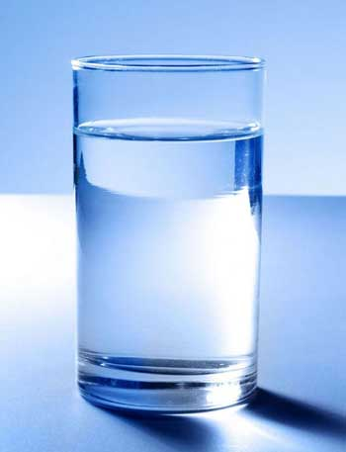
50-60% of our body is made up of water. Breathing, temperature regulation and sitting still cause us to look between ½ to 1 litres of fluid per day.

We need between 2.7 and 3.7 Litres of water a day.

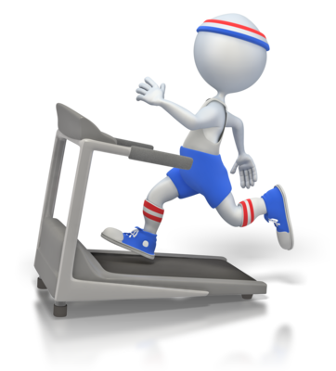

Exercises increases body temperature and we lose more fluid in sweat.

It is important to drink before during and after a session to restore the correct fluid levels.

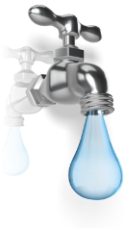
Dehydration
- Dehydration is caused when we lose more fluid than we are drinking.
- This is often due to sweating during exercise.
- Even swimmers sweat which causes fluid loss.
- Dehydration leads to muscle cramps, poor performance, poor concentration and can lead to more serious problems if severe.
- You need to drink more when exercising and also in warm weather or warm environments.

How to check for Dehydration
- The best way is to look at the colour of your urine and see if you are hydrated.
- On the colour chart 1, 2 and 3 are hydrated
- 4-8 are dehydrated

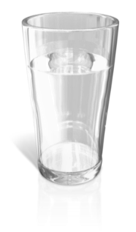
How to stay Hydrated
- Drink little and often
- Always have a drinks bottle with you even at school
- Drink water or cordial as the main fluid used to hydrate
- Fruit juices and Smoothies are less hydrating than water
- Drinks including Caffeine cause greater urine loss so can increase Dehydration
- Avoid Fizzy drinks and those with high sugar levels
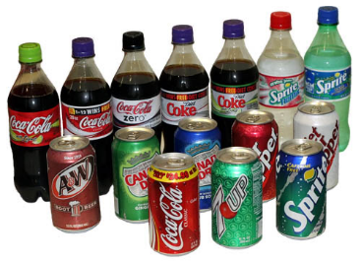

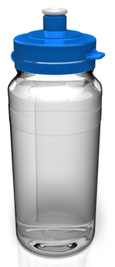
Training Fluids
- Water based drinks
- No need for sports drinks in most training sessions
- Make sure you start the session well hydrated

Before a session
- 2 hours before a session
  - Drink ½ litre of water in small sips.
  - Drink a further 125ml-250ml just before training.

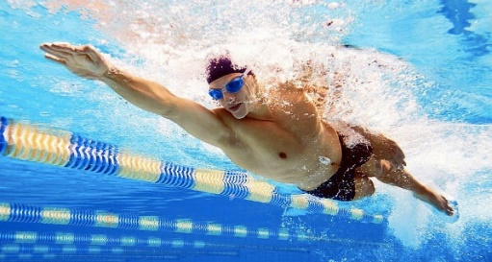
During Exercise
- Drink small amounts of water or cordial regularly.
- Aim for 125ml-250ml every 20 minutes.
- That works out at 1 ½ litres in a 2 hour session.

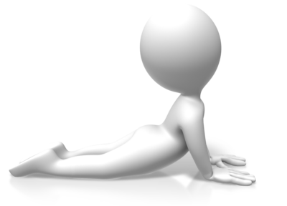
After Exercise
- Make sure you have a drinks bottle when doing your stretches.
- You need to drink approximately ½ a litre straight after exercise and then continue with little sips of water or cordial after this time.

